MY PORTFOLIO
Personal Portfolio Webpage
Consolidated Project Report
B.Tech CSE Student | Web Developer
HTML + CSS | Beginner Web Development Project

1. Project Overview
Project name: My Portfolio – Personal Portfolio Webpage
Objective: To create a simple personal portfolio webpage that introduces the student, presents education and skills, and provides contact information.
Technologies used: HTML for webpage structure and CSS for styling and layout.
Design theme: Purple, pink, white, and a light pink background for a colorful portfolio look.

2. Webpage Preview
MY PORTFOLIO
Hemanth\nB.Tech CSE Student | Web Developer
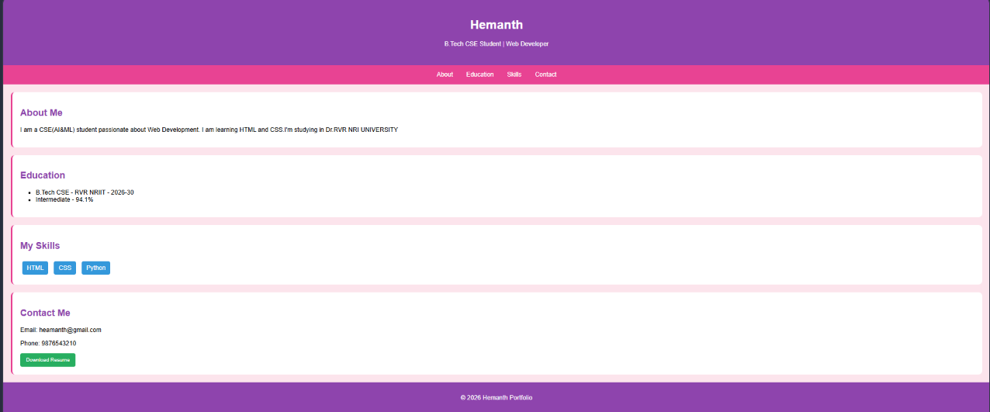
Figure 1. Preview layout recreated from the HTML and CSS supplied.

3. Main Features
Feature | Description
Header | Displays the student name and the role “B.Tech CSE Student | Web Developer”.
Navigation menu | Links to About, Education, Skills, and Contact sections.
About section | Brief introduction and interest in web development.
Education section | Shows B.Tech CSE details and Intermediate percentage.
Skills section | Displays HTML, CSS, and Python as skill labels.
Contact section | Shows email, phone number, and a Download Resume button.
Footer | Displays the copyright year and portfolio owner name.

4. HTML and CSS Summary
HTML defines the header, navigation links, content sections, skill labels, contact details, button, and footer. CSS controls the font, background colors, spacing, section borders, rounded corners, navigation styling, and button appearance.
The navigation links use section IDs (such as #about and #contact) to move to the matching sections on the page.

5. Limitations
The Download Resume button is visual only. No download action is connected in the supplied code. The email and phone number are displayed as text, and no contact form or backend is included.

6. Conclusion
My Portfolio is a beginner-friendly static webpage demonstrating basic HTML and CSS concepts. It introduces a student, shows education and skills, and shares contact details. JavaScript and a real resume file can be added later to make the resume button functional.

Appendix A – Source Code
<!DOCTYPE html>
<html>
<head>
<title>My Portfolio</title>

<style>
body {
font-family: Arial;
margin: 0;
background: #fce4ec;
}

header {
background: #8e44ad;
color: white;
text-align: center;
padding: 30px;
}

nav {
background: #e84393;
padding: 15px;
text-align: center;
}

nav a {
color: white;
text-decoration: none;
margin: 15px;
}

section {
background: white;
margin: 20px;
padding: 20px;
border-radius: 10px;
border-left: 5px solid #e84393;
}

h2 {
color: #8e44ad;
}

.skill {
background: #3498db;
color: white;
padding: 8px 12px;
border-radius: 5px;
display: inline-block;
margin: 5px;
}

button {
background: #27ae60;
color: white;
padding: 10px 15px;
border: none;
border-radius: 5px;
}

footer {
background: #8e44ad;
color: white;
text-align: center;
padding: 15px;
}
</style>
</head>

<body>

<header>
<h1>Hemanth</h1>
<p>B.Tech CSE Student | Web Developer</p>
</header>

<nav>
<a href="#about">About</a>
<a href="#education">Education</a>
<a href="#skills">Skills</a>
<a href="#contact">Contact</a>
</nav>

<section id="about">
<h2>About Me</h2>
<p>I am a CSE(AI&ML) student passionate about Web Development.
I am learning HTML and CSS.I'm studying in Dr.RVR NRI UNIVERSITY</p>
</section>

<section id="education">
<h2>Education</h2>
<ul>
<li>B.Tech CSE - RVR NRIIT - 2026-30</li>
<li>Intermediate - 94.1%</li>
</ul>
</section>

<section id="skills">
<h2>My Skills</h2>
<span class="skill">HTML</span>
<span class="skill">CSS</span>
<span class="skill">Python</span>
</section>

<section id="contact">
<h2>Contact Me</h2>
<p>Email: heamanth@gmail.com</p>
<p>Phone: 9876543210</p>
<button type="button">Download Resume</button>
</section>

<footer>
<p>© 2026 Hemanth Portfolio</p>
</footer>

</body>
</html>

